

Faculty of Computers and Artificial Intelligence

Computer Science Department

2021/2022

**CS 395 Selected Topics in CS-1**

**Research Project**

Report Submitted for Fulfillment of the Requirements and ILO’s for Selected Topics in CS-1 course for Fall 2021

Team No. ****

|  |  |  |  |
| --- | --- | --- | --- |
|  | ID | Name | Grade |
|  | 201900548 | فادى ملاك عطيه ميخائيل |  |
|  | 201900881 | مينا فوزى فايز مينا |  |
|  | 201900179 | امير حنا ثابت فهيم |  |
|  | 201900603 | مارينا رومانى نصر شنودة |  |
|  | 201900206 | ايمان محمد محمود عبد الحميد |  |
|  | 201900199 | اياد ايمن محمد مصيلحى |  |
|  | 201900020 | احمد امير احمد شفيق |  |
|  | 201600253 | حازم حافظ محمد حافظ |  |

Delivered to:

**Dr. Wessam El-Behaidy**

**Eng. Islam Gamal**

**Eng. Muhammed Kamal**

I. NUMERICAL DATASET

1. Project Introduction

* 1. **Dataset Name**

(What is the dataset used?)

* 1. **Number of classes and their labels**

(Specify number of classes and their labels.)

There are 2 Classes

Labels:

1 - Spruce/Fir  
2 - Lodgepole Pine

* 1. **Dataset Samples Numbers**

(The total number of samples in dataset)

500K Samples

* 1. **Training, Validation and Testing**

(The number of samples used in training, validation and testing.)

Training = 75% (375K)

Testing = 25% (125K)

1. Implementation Details
   * 1. **Extracted Features**

(How many features were extracted, their names, the dimension of resulted features)

* + 1. **Cross-validation**

(Is cross-validation is used in any of implemented models? If yes, specify the number of fold and ratio of training/validation)

* + 1. **Artificial Neural Network (ANN)**
* **Hyper-parameters**

(Specify all the hyper-parameters (initial learning rate, optimizer, regularization, batch size, no. of epochs…) with their specified value in implementation)

* + 1. **Support Vector Machine** **(SVM)**
* **Hyper-parameters**

(Specify all the hyper-parameters (optimizer, regularization, …) with their specified value in implementation)

1. Models Results

**For each model you should show all these results for your model on testing data** (loss curve, accuracy, confusion matrix, ROC curve)

* 1. 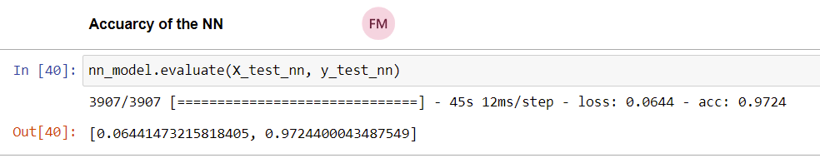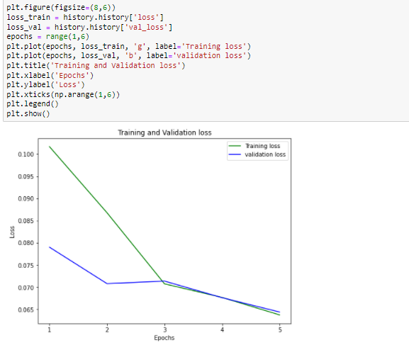**ANN Results**

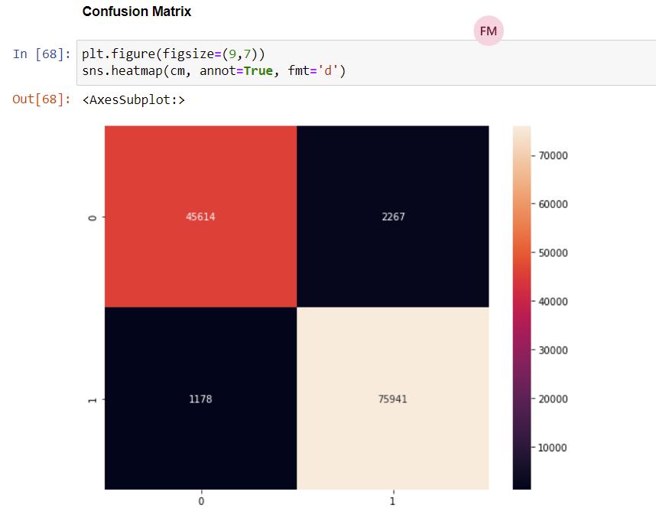

* 1. 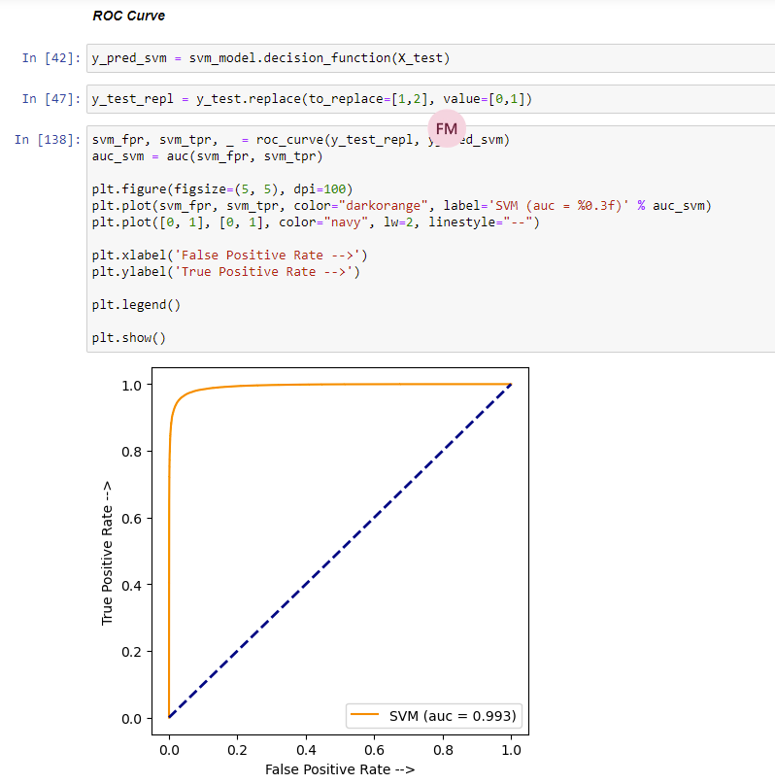**SVM Results**

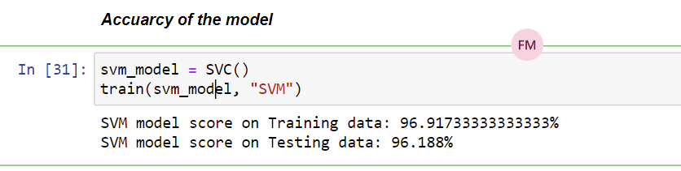

II. IMAGE DATASET

1. Project Introduction

* 1. **Dataset Name**

(What is the dataset used?)

Bayern

* 1. **Number of classes and their labels**

(Specify number of classes and their labels.)

5 Classes

Labels:

1. Kingsley Coman
2. Joshua Kimmich
3. Robert Lewandowski
4. Manuel Neuer
5. Leory Sane
   1. **Dataset Images Numbers and size**

(The total number of images in dataset and the size of each.)

The data contains 230 images

Each image is 64 * 64 Pixels

Data contains 5 Classes

* 1. **Training, Validation and Testing**

(The number of images used in training, validation and testing.)

**Number of Training data: 172 (75%)**

**Number of Testing data: 58 (25%)**

2. Implementation Details

* + 1. **Extracted Features**

(How many features were extracted, their names, the dimension of resulted features)

* + 1. **Cross-validation**

(Is cross-validation is used in any of implemented models? If yes, specify the number of fold and ratio of training/validation)

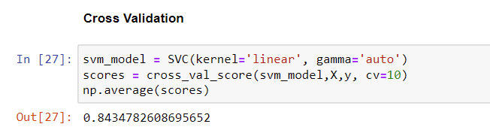

* + 1. **Artificial Neural Network (ANN)**
* **Hyper-parameters**

(Specify all the hyper-parameters (initial learning rate, optimizer, regularization, batch size, no. of epochs…) with their specified value in implementation)

batch_size = 10.

epochs = 8.

optimizer = Adam

learning_rate = 0.0001.

loss = 'categorical_crossentropy'.

* + 1. **Support Vector Machine** **(SVM)**
* **Hyper-parameters**

(Specify all the hyper-parameters (optimizer, regularization, …) with their specified value in implementation)

cv=10 , gamma =’auto’ ,Kernel= ‘linear’

3. Models Results

**For each model you should show all these results for your model on testing data** (loss curve, accuracy, confusion matrix, ROC curve)

* 1. 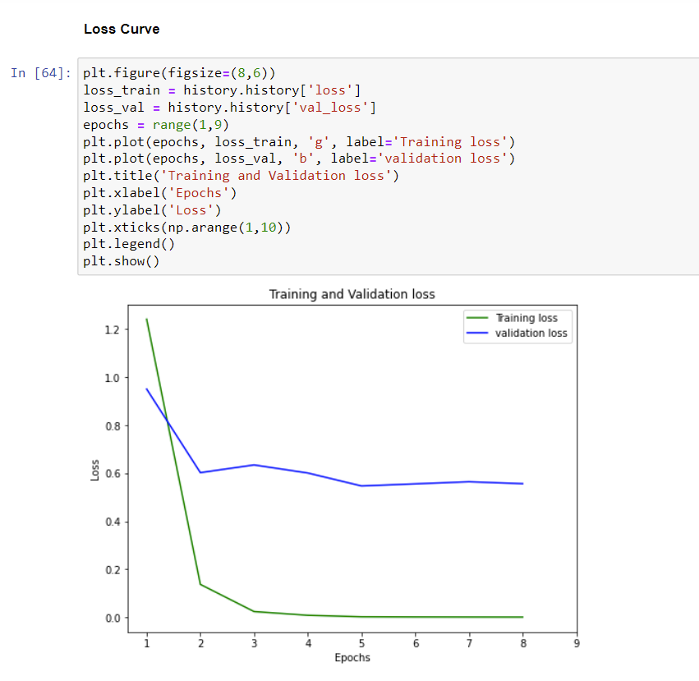**ANN Results**

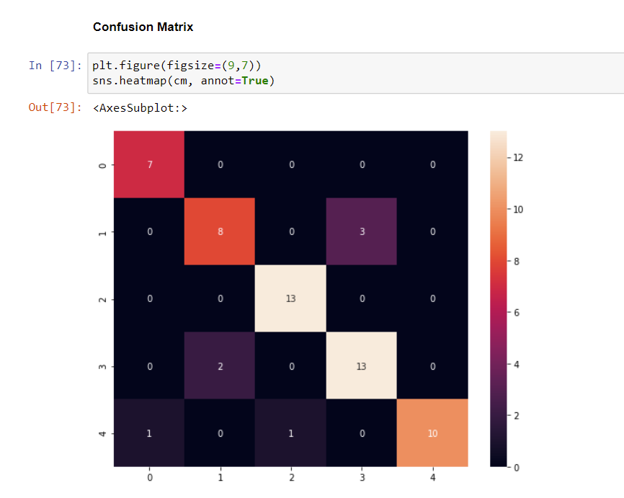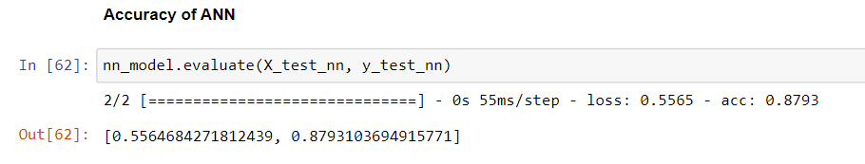

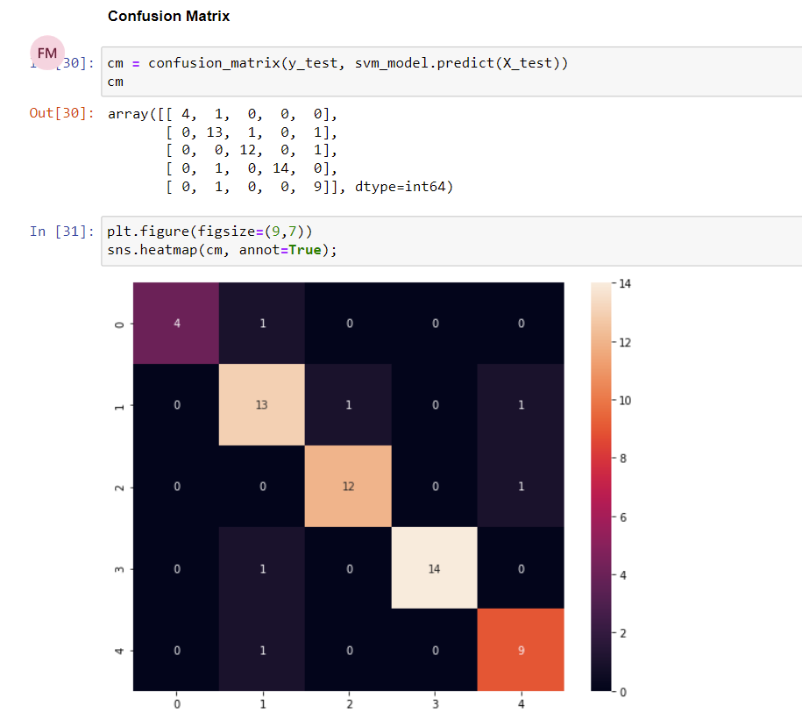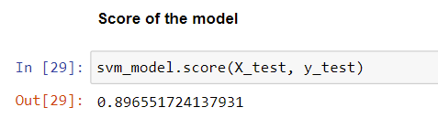**b.SVM Results**

